
MATHEMATICS APPLICATIONS

Investigation 4, 2018

Normal Distribution

ALL working must be shown for full marks. Name: _______________
Calculators allowed Total: /50 = _______%

Part A : z-Scores
Anna and Ben attend two different schools and were comparing their recent English results. Ben was saying he was a much better student as he had received 66% while Anna received 54%. Anna pointed out that they could not compare the different tests as one may have been more difficult than the other.

Anna’s Test: 54% Ben’s Test: 66%
Mean : 52% Mean : 72%
Standard deviation : 2 Standard deviation : 3

Question One (2,2,2,2= 8 marks)
- For the information above
i) What do the different Means tell us about the two tests?

ii) What do the different Standard Deviations tell us about the two tests?

To compare their scores we need to calculate how many standard deviations each student is above or below the mean.
- How many standard deviations is Anna above or below the mean.

- How many standard deviations is Ben above or below the mean.

- Who is really the better student? Explain your answer.

Question Two (3 marks)
The number of standard deviations above the mean is known as a standardized score
(or z-score) so z-score = score - mean
St dev

- Why would you use a z-score rather than a raw score?

- Ben had a raw score of 66%, what would be Ben’s z-score?

- Using the symbols σ for standard deviation and 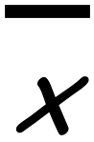 for mean and x for each score. Give an equation that could be used to calculate a z-score.

Question Three (4 marks)
Find the z-scores for the following students and order them from best to worst student.

Emma Bill Mandy
Raw Score: 32% Raw Score: 66% Raw Score: 82%
Mean: 20% Mean: 71% Mean: 80%
Standard dev: 6 Standard dev: 5 Standard dev: 4

Part B : Normal Distribution
Emily wanted to know how many seconds it would take to hear the first pop sound when cooking a bag of microwave popcorn. She asked her friends to repeat the same experiment, the data they collected is given in the table below.
TIME IN SEC | TALLY | FREQUENCY
19.5 ‹ x ‹ 24.5 | ¤
24.5 ‹ x ‹ 29.5 | ¤
29.5 ‹ x ‹ 34.5 | ¤¤
34.5 ‹ x ‹ 39.5 | ¤¤¤
39.5 ‹ x ‹ 44.5 | ¤¤¤¤
44.5 ‹ x ‹ 49.5 | ¤¤¤¤¤ ¤¤
49.5 ‹ x ‹ 54.5 | ¤¤¤¤¤ ¤¤¤¤¤ ¤
54.5 ‹ x ‹ 59.5 | ¤¤¤¤¤ ¤¤¤¤¤ ¤¤¤¤¤
59.5 ‹ x ‹ 64.5 | ¤¤¤¤¤ ¤¤¤¤¤ ¤¤¤¤¤ ¤¤¤
64.5 ‹ x ‹ 69.5 | ¤¤¤¤¤ ¤¤¤¤¤ ¤¤¤¤¤ ¤¤¤¤
69.5 ‹ x ‹ 74.5 | ¤¤¤¤¤ ¤¤¤¤¤ ¤¤¤¤¤ ¤¤¤¤¤
74.5 ‹ x ‹ 79.5 | ¤¤¤¤¤ ¤¤¤¤¤ ¤¤¤¤¤ ¤¤
79.5 ‹ x ‹ 84.5 | ¤¤¤¤¤ ¤¤¤¤¤ ¤¤¤¤
84.5 ‹ x ‹ 89.5 | ¤¤¤¤¤ ¤¤¤¤¤
89.5 ‹ x ‹ 94.5 | ¤¤¤¤¤ ¤¤¤
95.5 ‹ x ‹ 99.5 | ¤¤¤¤¤
99.5 ‹ x ‹ 104.5 | ¤¤¤
104.5 ‹ x ‹ 109.5 | ¤¤
109.5 ‹ x ‹ 114.5 | ¤
114.5 ‹ x ‹ 119.5 | ¤
119.5 ‹ x ‹ 124.5
Question Three (1 marks)
Complete the frequency column for the table.

Question Four (2,1,1,1,1 = 6 marks)
- Construct a Histogram for the time in seconds the popcorn took to pop.
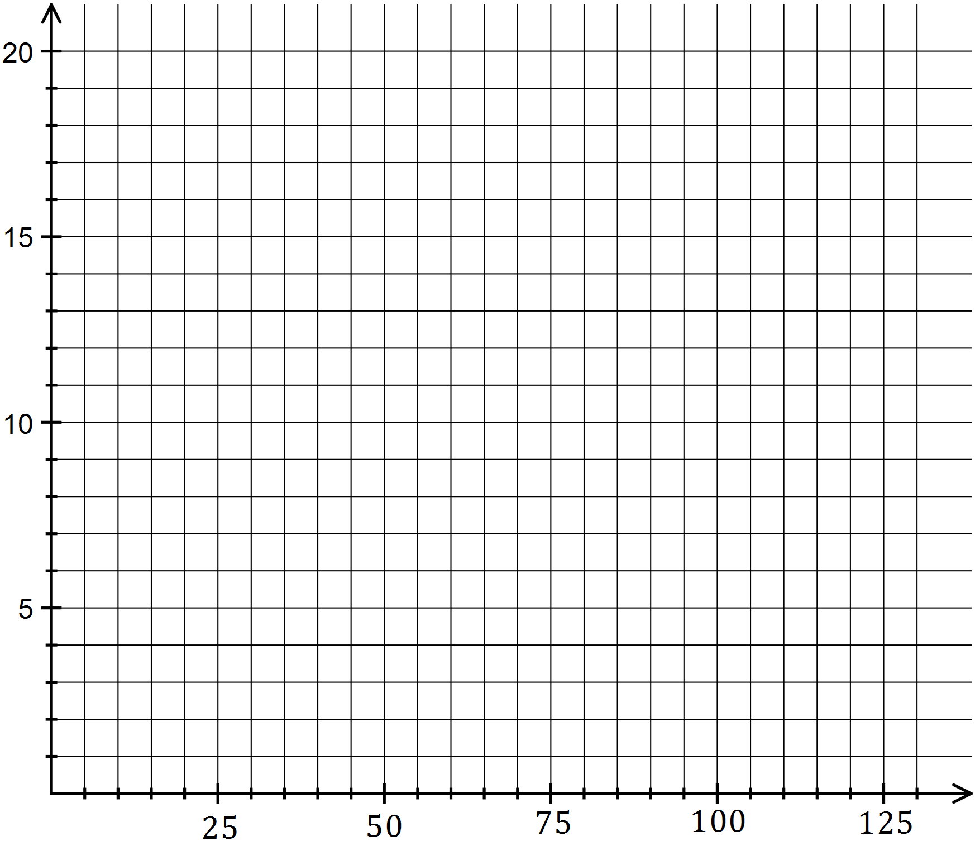

- Where is the peak of the histogram?

- Is the histogram roughly symmetrical?

- What do you notice about the shape of the graph at the very high and very low popping times?

- Place a dot at the top of each histogram column and join the dots to form a curve.
(a column with a frequency of zero will still be included)

Question Five (2, 2, 2 = 6 marks)
- Calculate the Mean and Standard Deviation time in seconds for the popcorn to pop.
(to the nearest whole number)

- Show the position of the mean as a vertical line on the graph from Question Four.
What do you notice?

- i) Show the position of one, two and three standard deviations above the mean
using 3 vertical lines on the graph from Question Four.

ii) Show the position of one, two and three standard deviations below the mean
using 3 vertical lines on the graph from Question Four.

Question Six (3, 3 = 6 marks)
- Calculate the total number of popcorn bags who have a popping time:
i) between one standard deviation either side of the mean.

ii) between two standard deviation either side of the mean.

iii) between three standard deviation either side of the mean.

- Given there are 162 bags of popcorn in total, give the probability (as a percentage) that a randomly selected bag of popcorn will be:
i) between one standard deviation either side of the mean.

ii) between two standard deviation either side of the mean.

iii) between three standard deviation either side of the mean.

Question Seven (2, 2, 2, 2 = 8 marks)
Below is the histogram of the shoe sizes of 122 year 7 students.
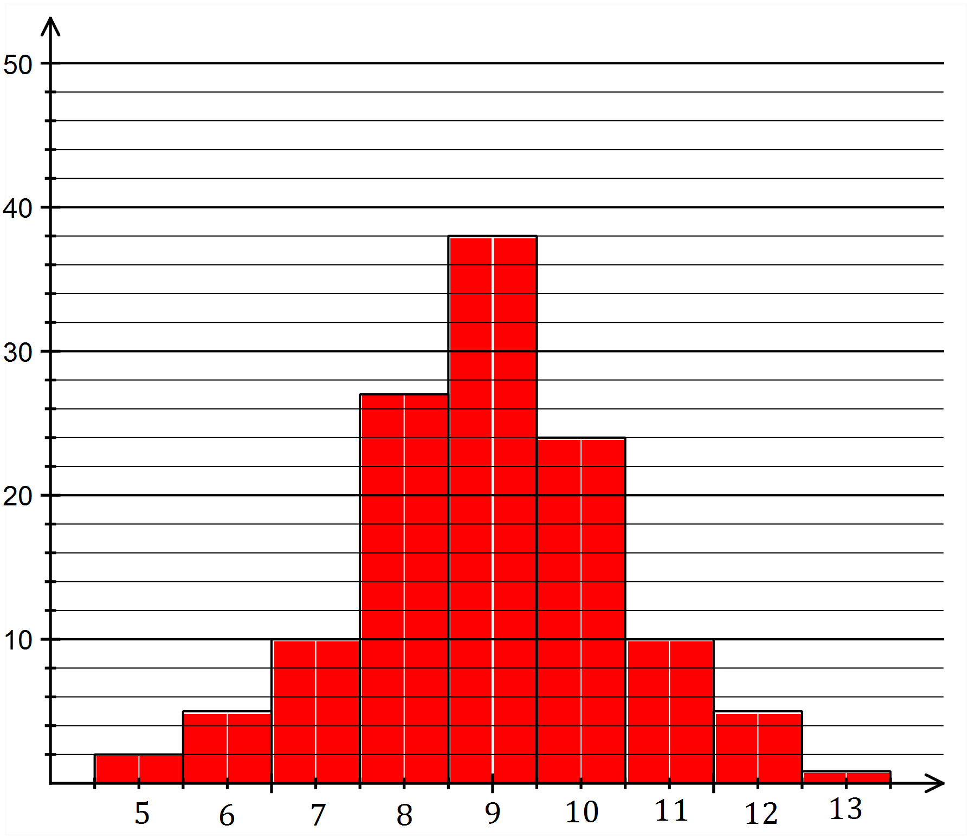

- Place a dot at the top of each histogram column and join the dots to form a curve.

The curve made from these points is known as a ‘bell curve’ and is made when the data is normally distributed. Normal distribution occurs when a naturally occurring item is measured. eg Heights of children or the times to swim 100m at a swimming carnival

- Calculate the mean and standard deviation for the information in the histogram.
(to the nearest whole number)

- Show the position of the mean as a vertical line on the graph from Question Seven.
What do you notice?

- i) Show the position of one, two and three standard deviations above the mean
using 3 vertical lines on the graph from Question Seven.

ii) Show the position of one, two and three standard deviations below the mean
using 3 vertical lines on the graph from Question Seven.

Question Eight (3, 3, 2 = 8 marks)
- Calculate the total number of year 7 students who have a shoe size:

i) between one standard deviation either side of the mean.

ii) between two standard deviation either side of the mean.

iii) between three standard deviation either side of the mean.

Given there are 122 year 7 students in total,

- Give the probability (as a percentage)that a randomly selected year 7 student will have a shoe size:
i) between one standard deviation either side of the mean.

ii) between two standard deviation either side of the mean.

iii) between three standard deviation either side of the mean.

- What do you notice?

